Rate My _____

CS 411

April 5, 2016

Project Assignment 5

Updated Version on April 29, 2016

Original Data Model Using SQL:



Note that we have switched to mongo instead of SQL

Sequence Diagram for out FaceBook Login API:

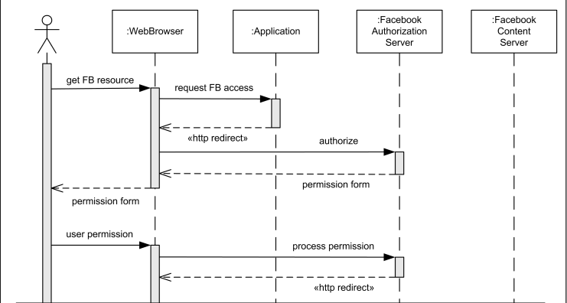

Sequence Diagram for our full text search:

